Objective
FAS Applications Security team is updating the security request forms to an online “smart” form. Only designated authorized requestors for each department will be able to access the forms for submission. The list of these authorized staff members consists of current departmental requestors and can be modified in consultation with AppSec.

Overview
Why
The new form will allow for a more intuitive process for requesting access to the numerous FAS and University wide systems used by staff. By using the drop-down menus, the chance of errors will be reduced as administrators navigate the access choices. The current request process does not have any access control, which means that the App Sec team must manually confirm that each request for access is from a valid requestor.
Who
Select Harvard University employees have been designated by their department to authorize users for system access.
What
The new Applications Security smart forms will allow authorized requestors to make better informed choices as they assign access to critical financial and HR systems used by FAS employees. As choices are made the form will automatically update to allow users to provide additional details necessary to complete the request. Note: Chrome is the preferred browser for this form.
When
The new forms will be made available on February 25th. AppSec will continue to accept the older forms until April 15th, but we encourage you to please start using the updated forms at this time.
Where
The link to the smart forms will be available on the FAS Office of Finance site, in the Resources section, under Forms.
Features
- Interactive form that eliminates the risk of requesting conflicting access
- Drop down lists to avoid typographical errors
- Quick navigation to only the applications being requested

Benefits
- Enables paperless system authorization: All paperwork (certificates of completion, etc.) in the process can be attached to the request form.
- Users can request a copy of the access request to be sent to them for future reference.
- Reduced errors due to clearer forms: new forms will reduce errors and decrease back and forth questions. Central still requires 48hr turnaround time once the request is processed.
Access
As a designated authorized requestor for your department, you will be sent an email from HUIT to collaborate on Smartsheet. Click ‘Accept’.
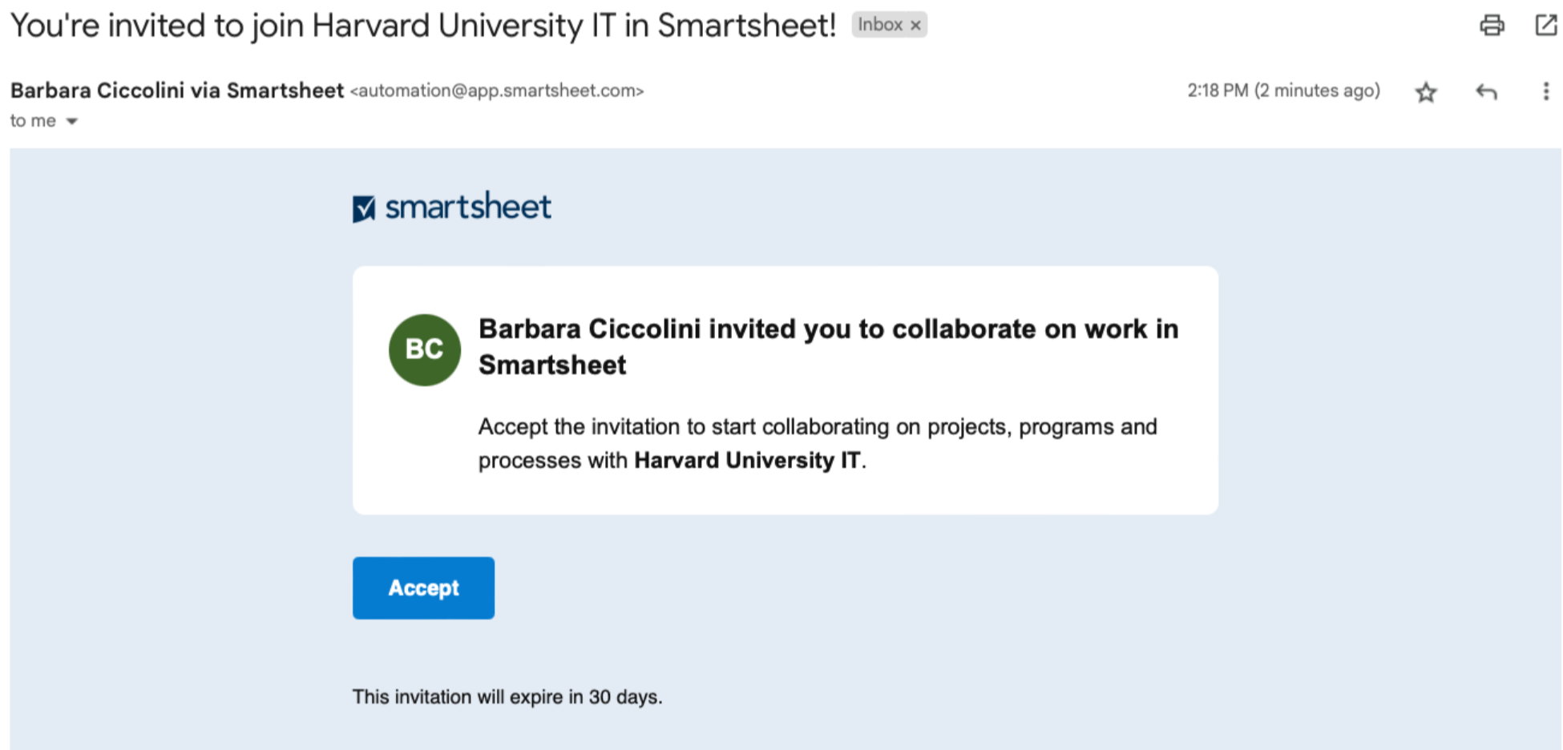
Click Accept

A browser window will open ‘Welcome to Smartsheet’, click ‘Accept’.
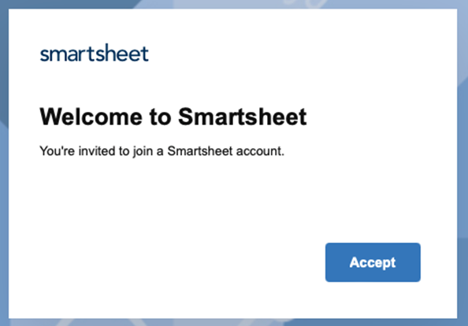
Click Accept

Sign in with your Harvard Key as your ‘company account’.
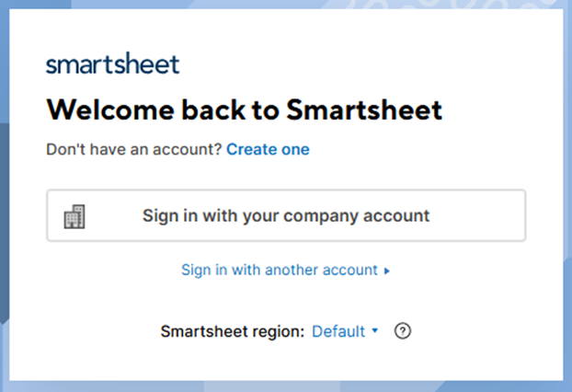
Enter Harvard Key

After signing in, click on the ‘Office of Finance System Access Request Form’ available at https://finance.fas.harvard.edu/pages/system-access
Questions
If you have a specific question regarding the completion of the new Applications Security forms, please contact appsec@fas.harvard.edu.

