
Preparing Student Quick Hire Form
- Log into PeopleSoft and navigate to the following:
  - Harvard Processes>Entry/Forms>Hire Student – Prepare/Submit
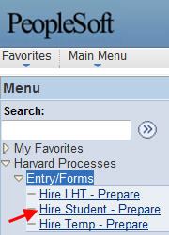
- Click “Add New Value” tab
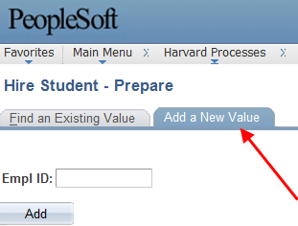
- Type in Student’s HUID, click Add
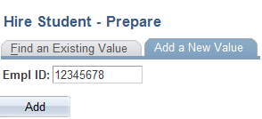

- Enter the following Job Information into PeopleSoft: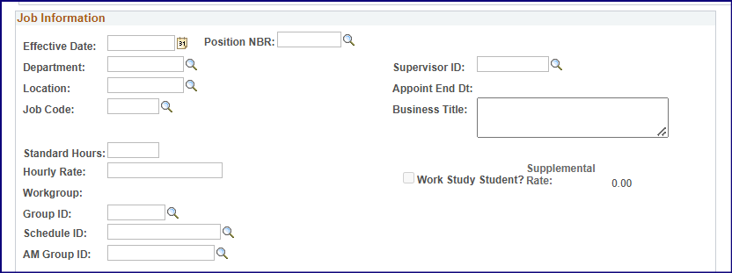
- Effective Date: Enter start date of Student
- Department: Enter the PeopleSoft ‘Student/Temp’ Department number, not the ‘Parent’ department number.
  - Update via Search (magnifying glass) option (this will be the same for all fields that have a search option).
    - For example you would enter in Department 102091 from the following search option:
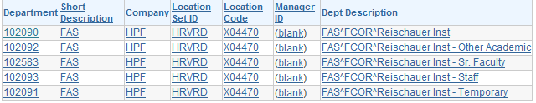

- Location: This field will automatically fill-in once a department is entered
- Job Code: This will default to Job Code 700030 Temporary Harv Student OT Elig.
- Standard Hours: Will default to 5.00.
- Hourly Rate: Enter hourly rate for Student
- Workgroup: TEMPOTELG will prefill.
  - Note: for work study students change to WSON-CAMP
- Group ID: Enter Time and Labor Group.
- Schedule ID: Enter in default schedule 40.00_S5M6T6W6R6F6S5
- Absence Group ID: Enter Absence Group
- Supervisor ID: Enter Supervisor HUID
- Appoint End Dt: Enter end date if known
- Work Study Student – Check if applicable

- Enter Costing Data:
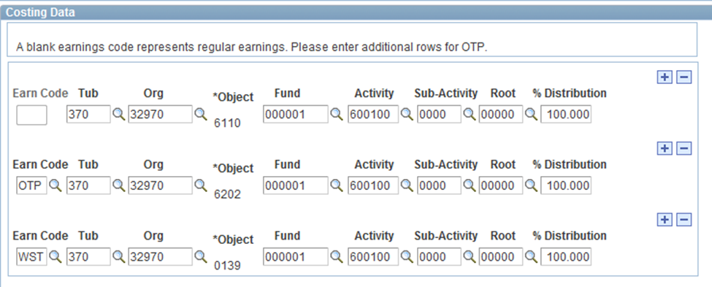
- The first line is designated for the REG salary (Blank Earn Code).
  - Enter a 33-digit coding for REG time and enter 100% for the distribution.
- If you want to split code for REG, click the + sign to enter a second 33-digit coding and designate the appropriate % in the second line.
  - Leave the Earn Code blank for the second REG line.
  - Note: The correct object code will be inserted automatically
- Click + sign to add two additional lines of coding:
- OTP is required
- WST is required (in the event that the student becomes Work-Study eligible)
- Select the appropriate next step in the Hire form status:

- Save Draft: Validates the coding and saves the work completed so far.
- Submit for Approval: If your access is Hire-Prepare, select ‘Submit for Approval’ and it will be forwarded within the department for additional approval.
- Submit for Database: If your access is Hire-Submit, select ‘Submit for Database’ to transmit the form for immediate processing.
- Reject Form: Click to reject form; Approvers have this functionality
- Delete: Click to delete form
- Print Form: Click to print form

