Descriptive Flex Field (DFF) for Non-Sponsored ADI Journals

What is the DFF?
The Descriptive Flex Field is required for journals that contain certain object codes, such as payroll. For a complete list of object codes that require the DFF, refer to the document ‘DFF_Object Codes and DFF Requirements’.

Why is the DFF needed?
The purpose of the DFF is to provide additional information related to the transaction that is being moved in the ledger so reporting can be accurate for an individual, as it relates to employee payroll, student loans, financial aid, Federal Work Study, etc. In the case of payroll, the original transaction in the G/L included the employee/student’s HUID and employee/student’s name. When a journal is required to change the coding for an individual, then this information must be included in the journal.

Why is the DFF format so important?
The DFF on the ADI must be written in a specific way so that the information will populate correctly in the fields in Oracle and ultimately in CREW reports once the journal posts. To visually explain this, below is a print screen from Oracle that shows the DFF information parsed out into 4 fields based on the following DFF from an ADI. The period between each segment is what separates the information into each field. For non-sponsored journals, no additional periods should be used after the name in the DFF as Oracle interprets the period as another field that doesn’t exist.

DFF Example
Below is a screen shot of the DFF sections required to be completed on the ADI template for a payroll object code, which is the most common type of DFF required. The object code in column M is the same code used in column E. The DFF format listed below in red and black is valid, so users may copy this into column N in the ADI and update the information as necessary while preserving the format.

Payroll.30-JUN-2016.6050.12345678.Harvard, John

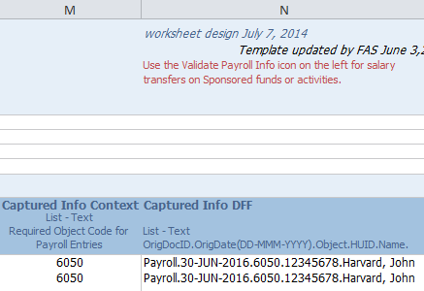

Based on the DFF in column N of the ADI template, Oracle breaks up the data into the following segments. Note that the object code is not one of the segments, but the object code is what determines which fields are required to be completed.

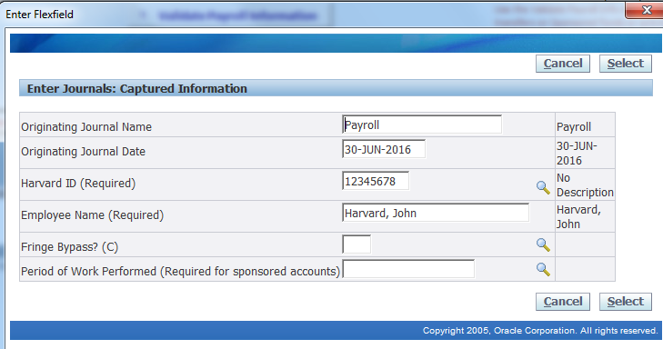
DFF Fields Defined

Originating Journal Name – we recommend using the word “Payroll” for payroll transactions (the most common DFF example), followed by a period (.).

Originating Journal Date – it must follow the exact format as shown in the example: DD-MMM-YYYY followed by a period (.). The month is 3 letters (not numbers) such as JUN – see complete list below. Also, the day/month/year are separated by dashes (-), not periods. Using periods here will give an upload error. The date is when the payroll was posted to the Detail Listing, not the period ending date. If you are journaling multiple pay periods, use the date of the last paycheck being journaled. Below is a listing of month abbreviations to use:

JAN, FEB, MAR, APR, MAY, JUN, JUL, AUG, SEP, OCT, NOV, DEC

Harvard ID (HUID) – Only use valid HUIDs with eight digits followed by a period (.). Do not use placeholder HUIDs such as “00000000” or “99999999.” Because this information is crucial to being able to run a report from the General Ledger on a particular person’s pay or financial aid, you must be able to identify the person involved.

Employee Name – written in the format Last Name, [comma] First Name Middle Initial (there is no period after the middle initial). Include the middle initial if it is used in the original payroll transaction; however it is not a requirement to have a middle initial in the DFF. There is a 30 characters limit on the full name. If you are doing a journal on an employee with a long name, eliminate the middle initial first, and then shorten the first name until the whole name is 30 characters or less. An example of a name that contains a middle initial is Harvard, John Q

Other things to note:

Do not use the following characters in the DFF fields – Oracle will not accept these in the upload
percent (%)
single quote(‘)
double quote (“)
period(.) Only use the 4 periods in the DFF example. Additional periods will not work.
greater than (>)
lesser than(<)
ampersand (&)

Fringe Bypass

When journaling a salary object code, the fringe object code should not be included in the journal. The fringe will be recorded automatically in the G/L via the Mass Allocation with the current year fringe rates. Since fringe rates change each fiscal year, there may be certain circumstances where it would not be appropriate to have the fringe automatically calculated on the current year fringe rates. Therefore, fringe would need to be bypassed and then included as a separate line on the journal with the fringe object code. This is not a common practice. To bypass the fringe, the DFF must include .C at the end of the DFF on the salary line of the journal. Below is an example:

Payroll.30-JUN-2016.6050.12345678.Harvard, John.C

