HCOM Internet Explorer v8 Settings - Quick Reference

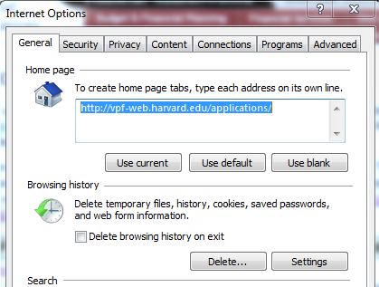
If you are having difficulties in HCOM, please check these settings to ensure that they are correct for this version of IE.
From the Menu bar, select ‘Tools’, ‘Internet Options’. At the first tab, select the ‘Delete’ button in the Browsing History section.

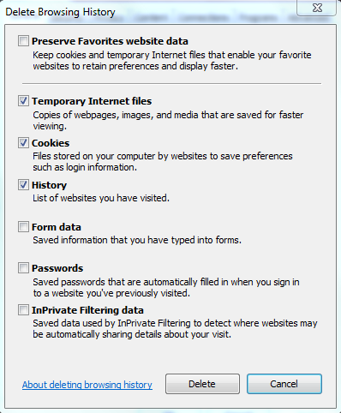
In the Delete Browsing History section, select #2-4 by checking the boxes to the left of the items you wish to delete.
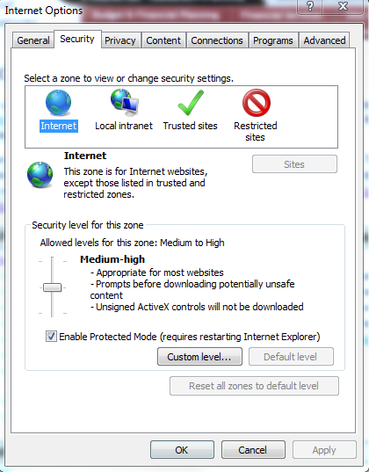
From the Security tab, press the ‘Custom level’ button near the bottom of the box.

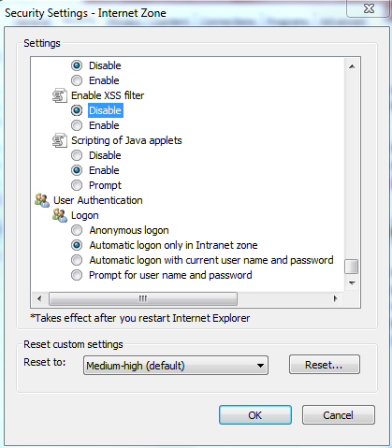
Near the bottom of the list of settings, find ‘Enable XSS filter’. Select ‘DIsable’ and press ‘OK’ to confirm your change.
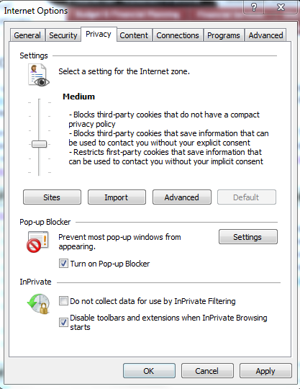
From the Privacy tab, select the ‘Advanced’ button to further customize your settings.

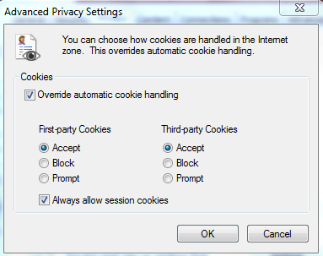
You will need to make three setting adjustments in this section:
- Select “Override automatic cookie handling
- Accept 1st and 3rd party Cookies
- Select ‘Always allow session cookies’

Press ‘OK’ to confirm your changes.

Once you have completed these setting changes, HCOM should function properly. If you are still experiencing problems with the application, please contact the HUIT Support Center at x6-2001 or UIS_helpdesk@harvard.edu.
Feb 2012

