**Procedure for Shoppers to add Attachments to Requisitions in HCOM**

Shoppers have the ability to add attachments to their requisitions. The option to add attachments appears in the **Checkout: Approvals and Notes screen** as shown below.

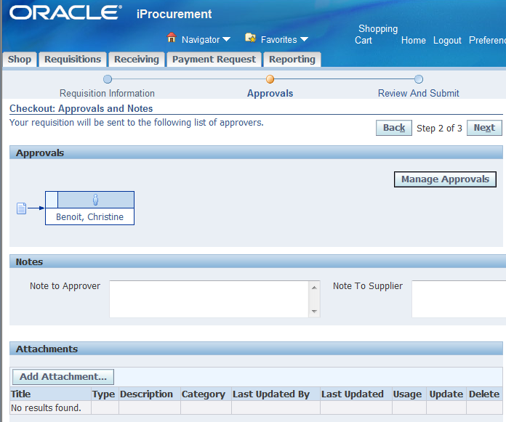

Please follow these steps to add attachments to your requisitions.

1. Click **Add Attachments** button. Screen will be displayed as shown below. There are 3 options for attachments – File , URL , Text.

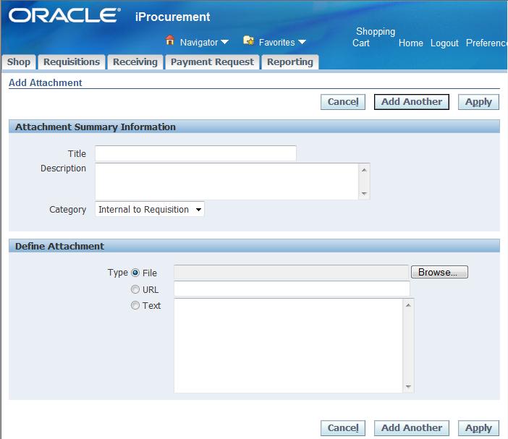

* 1. **Attaching a File:** Use this option to attach a file to the requisition.
     1. (OPTIONAL) - Enter a title for the attachment in the **Title** field. Enter a description of the attachment in the **Description** field
     2. Category will default to Internal to Requisition.
     3. Select **File** option and click **Browse** button. Screen will be displayed as shown below. Select the file you wish to attach and click **Open.**



1. Click **Apply**.

The attachment allows for information sharing between shoppers and approvers. Please note that AP cannot see this information.